Activity sheet 3.10 – Is it an element, compound or mixture?
1. Write definitions for the following:
A. element

B. compound

C. mixture

2. What is the difference between a compound and a mixture?

3. Identify each of the diagrams below as an element, compound or mixture.
A.  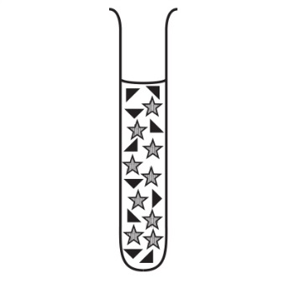  _________________ | B.  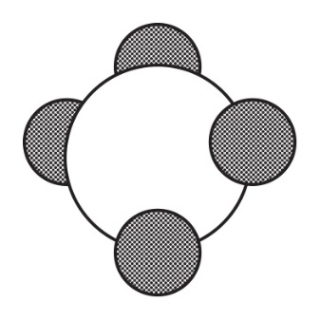  _________________ |  | C.  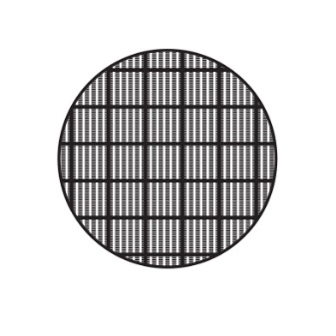  _________________
D.    ________________ | E.    ______________ |  | F.    _______________
G.
___________________

4. Complete the table below.

Chemical formula | Name and number of elements
CO₂ | 1 carbon, 2 oxygen
CaCO₃
KI
Fe₂O₃
Al₂O₃
NaCl

